| Item | Description | Additional Info | Person |
| --- | --- | --- | --- |
| Updates | * Profiles and Edit Page (Nicole)   + Gonna complete everything today * Rewards Page: (Bert)   + Input Functionality of deducting the points   + Need to change his widgets into List form. * Chat Functions, Transaction Logic and Function. (Johnny)   + Essentially all the features are up.   + Finish Implementing the Rate Feature * Report Page (Justin)   + There are still some functions to be completed.   + Uploading |  |  |
| Things to be done | * Improve UI? * Complete everything today, especially frontend. * Video Script * Are we still going with chatbot?!!??!?! * But the only one coding is Johnny XD? Shag johnny * Leftover diagrams that need to be need to be done |  |  |
| Video Flow | 1. Person trying to lift up the mahjong table, but that person beside |  |  |
| Architecture Diagram |  |  | Yue Chong |
| VIDEO FILMING DAY | * Wednesday 9.00am NorthSpine |  |  |
| Deliverables 3 | * Use Case Diagrams * Sequence Diagrams * Dialog Map (Jia Wei) * System Architecture (Yue Chong) * Application Skeleton (Everyone) * Compile Report (Bert) |  |  |
| Unit Testing | * Start after this week? |  |  |

Garbage dialog map:

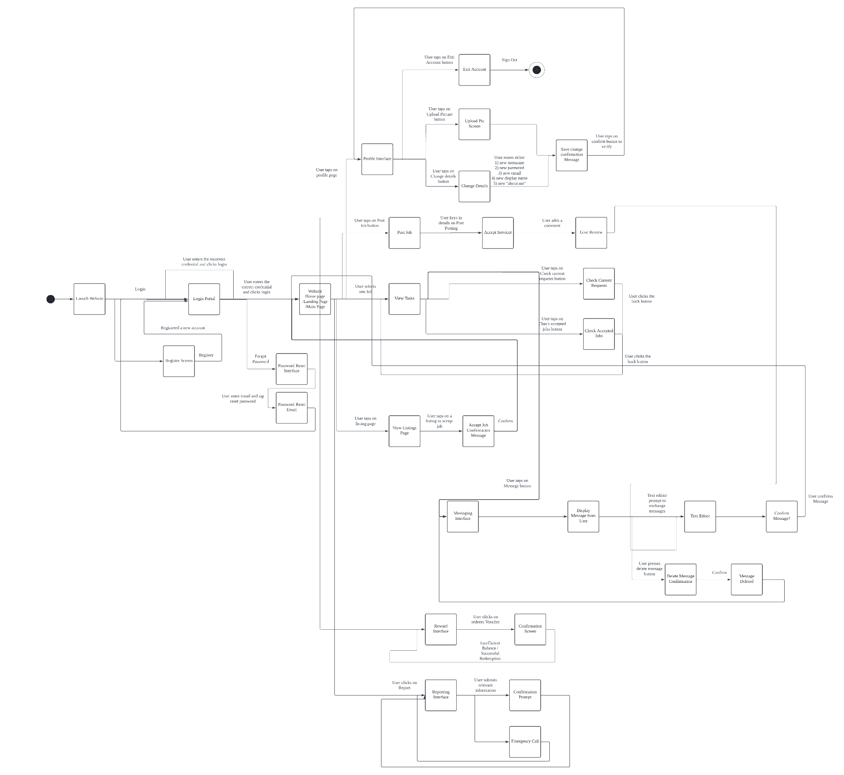

<https://lucid.app/lucidchart/69051ab2-1aab-4806-a388-81e60331132a/edit?viewport_loc=154%2C91%2C5450%2C2535%2C0_0&invitationId=inv_35cd005e-1bee-4b43-a953-d626d09b91e9>

Video Script:

DELIVERABLES 3

* Complete Use Case model
* Design Model
  + Class diagram
  + Sequence diagrams
  + Dialog map
* System architecture
* application skeleton